**A**

**Project Report on**

**“Bank Dataset”**

**Submitted at**

**Fortune Cloud Technology, Pune**

**Submitted by:**

Gauri Arun Pise

**Email:**

[gauripise190@gmail.com](mailto:gauripise190@gmail.com)

**Guided by:**

Varsha Patil

**Technology Used:**

Microsoft Excel

Microsoft Power BI

Tableau Public Edition

**Batch:**

6th Jan,2025

: ˙ . **Project Report: Spotify Dataset**

**INDEX**

|  |  |
| --- | --- |
| **Section** | **Title** |
| 1 | Project Title |
| 2 | Objective |
| 3 | Tools & Technologies Used |
| 4 | Insights (Chart by chart) |
| 5 | Screenshots |
| 6 | Challenges Faced |
| 7 | Conclusion |
| 7 | Future Scope |

**1)Project Title:** Bank Analysis Dashboard

**2)Objective:**

The objective of this dashboard is to provide a comprehensive overview of customer account activities, loan distribution, and credit utilization within the bank. It enables quick monitoring of key metrics such as customer demographics, account types, transaction activity, loan status, overdraft usage, and credit card adoption. This visualization aims to assist management in tracking financial performance, identifying trends, assessing risk, and supporting data-driven decisions for customer engagement and business growth.

**3)Tools and Technologies :**

From above dataset I have created three dashboards in which I used three tools :

a)Microsoft Excel

b)Microsoft Power BI

c)Tableau Public Edition

**4)Insights: Chart-by-chart analysis**

**A)Excel:**

1)Chart Type: Column chart

Insight: Branch wise customer distribution

Minimum count of customer: 19794 and Branch : North

Maximum count of customer: 20186 and Branch: East

2) Chart Type : Pie chart

Insight: Sum of overdraft used

Yes: 42185553.58(51%)

No: 41308949.02(49%)

3) Chart Type: Bar chart

Insight: Avg txn value comparison

Minimum txn value: 2502.69 and Account type: Saving

Maximum txn value: 2515.35 and Account type: Credit

4) Chart Type: Pie chart

Insight: Gender wise customer distribution

Minimum customer: 33279(33%) and Gender: Male

Maximum customer: 33363(34%) and Gender: Other

5) Chart Type: Line chart

Insight: Activity over trend

Minimum count of customer: 7657 and Month :Feb

Maximum count of customer : 8543 and Month : Dec

6) Chart Type: Column chart

Insight: Transaction per branch

Minimum transaction: 49417588 and Branch: North

Maximum transaction: 50305400 and Branch: East

7) Chart Type: Area chart

Insight: Sum of loan amount by year

Minimum loan amount: 8295121.4 and Year: 2015

Maximum loan amount: 724292713.7 and Year: 2025

8) Chart Type: Column Chart

Insight: Currency wise customer distribution

Minimum customer: 24825 and Currency: EUR

Maximum customer: 25268 and Currency: USD

9) Chart Type: Pie Column

Insight: Customer distribution loan type wise

Minimum customer: 7411 (7%) and Loan type: Personal

Maximum customer: 70114(8%) and Loan type: Unknown

**B)Microsoft Power Bi:**

1) Chart Type: Column chart

Insight: Average transaction value by branch

Minimum avg txn amount: 2506.434 and Branch: East

Maximum avg txn amount:2514.494 and Branch: South

2) Chart Type: Donut chart

Insight: Customer count by branch

Minimum customer count: 19794(19.79%) and Branch: North

Maximum customer count: 20186(20.19%) and Branch: East

3) Chart Type: Treemap chart

Insight: Sum of balance by branch

Minimum balance: 1985950047.37 and Branch: South

Maximum balance: 2016907910.73 and Branch: West

4) Chart Type: Donut chart

Insight: Count of customer id by currency

Minimum count: 24825(24.83%) and Currency: EUR

Maximum count: 25268(25.27%) and Currency: USD

5) Chart Type: Stacked bar chart

Insight: Top 10 customer id by balance

Minimum balance: 19995.19

Maximum balance: 199977.7

6) Chart Type: Stacked column chart

Insight: Account types across genders

Checking: Minimum customer count: 11064 and Gender: Male

Maximum customer count: 11139 and Gender: Other

Credit: Minimum customer count: 11047 and Gender: Other

Maximum customer count: 11114 and Gender: Male

Savings: Minimum customer count: 11101 and Gender: Male

Maximum customer count: 11177 and Gender: Other

7) Chart Type: Area chart

Insights: Sum of loan amount by year

Minimum loan amount: 8295121.39 and Year: 2015

Maximum loan amount: 724292713.64 and Year: 2025

8) Chart Type: Area chart

Insights: Customer activity trend over time

Minimum customer count: 130 and Year: 2015

Maximum customer count: 9756 and Year: 2025

9) Chart Type: Stacked column chart

Insights: Average loan amount by loan type

Minimum loan amount: 74507.26 and Loan type: Education

Maximum loan amount: 77386.80 and Loan type: Auto

10) Chart Type: Stacked bar chart

Insights: Loan products popularity wise

Minimum customer count: 7360(7.36%) and Loan type: Auto

Maximum customer count: 70114(70.11%) and Loan type: Unknown

11) Chart Type: Donut chart

Insights: Count of patient id by account type

Minimum patient id count: 33265(33.27%) and Account type: Credit

Maximum patient id count:33429(33.43%) and Account type: Savings

12) Chart Type: Funnel chart

Insights: Sum of avg txn amount by account type

Minimum txn amount: 83522530.67 and Account type: Checking

Maximum txn amount: 83762862.29 and Account type: Savings

13) Chart Type: Donut chart

Insights: Credit card distribution

Yes: Count of credit card flag: 49685(49.69%)

No: Count of credit card flag: 50315(50.32%)

14) Chart Type: Clustered column chart

Insights: Count of customer id by gender

Minimum customer count: 33279(33.28%) and Gender: Male

Maximum customer count: 33363(33.36%) and Gender: Other

15) Chart Type: 100% stacked column chart

Insights: Count of customer id by loan type and gender

Minimum customer count: 7360 and Loan type: Auto

(Male: 2479, Female:2392, Other: 2489)

Maximum customer count: 70114 and Loan type: Unknown

(Male: 23339,Female: 23450, Other: 23325)

**C) Tableau Public Edition**

1) Chart Type: Bar chart

Insight: Branch wise loan amount

Minimum loan amount: 1472528234 and Loan amount: North

Maximum loan amount: 1516559794 and Loan amount: West

2) Chart Type: Line chart

Insight: Activity over time

Minimum customer count: 130 and Year: 2015

Maximum customer count: 9756 and Year: 2025

3) Chart Type: Pie chart

Insight: Loan type wise loan amount

Minimum loan amount: 559575297 and Loan type: Personal

Maximum loan amount: 5235505415 and Loan type: Unknown

4) Chart Type: Treemap

Insight: Transaction per branch

Minimum transaction: 49417588 and Branch: North

Maximum transaction: 50305400 and Branch: East

5) Chart Type: Bubble chart

Insight: Currency wise balance

Minimum balance: 2489802384 and Currency: EUR

Maximum balance: 2529195182 and Currency: USD

6) Chart Type: Horizontal bar chart

Insight: Branch wise customer distribution

Minimum customer count: 19794 and Branch: North

Maximum customer count: 20186 and Branch: East

7) Chart Type: Sided-by-side bars

Insight: Loan type wise gender distribution

Minimum customer count: 7360 and Loan type: Auto

(Male: 2479, Female:2392, Other: 2489)

Maximum customer count: 70114 and Loan type: Unknown

(Male: 23339,Female: 23450, Other: 23325)

8) Chart Type: Pie chart

Insight: Account type wise customer count

Minimum patient id count: 33265(33.27%) and Account type: Credit

Maximum patient id count:33429(33.43%) and Account type: Savings

9) Chart Type: Table bars

Insight: Branch Overview

Minimum customer count: 19803, and Branch: South

(Avg txn amount: 49794530 , Balance: 1985950047)

Maximum customer count: 20096, and Branch: West

(Avg txn amount: 50436585 , Balance: 2016907911 )

**5)Screenshots:**

**A)Excel Dashboard**

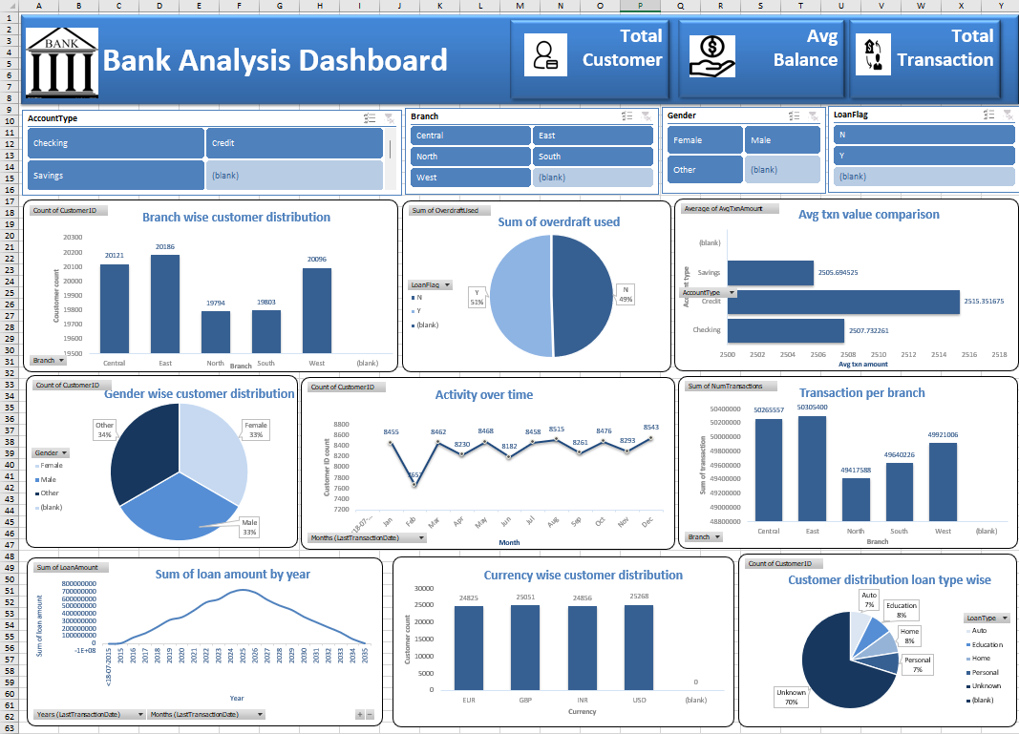

**B)Microsoft Power BI Dashboard:**

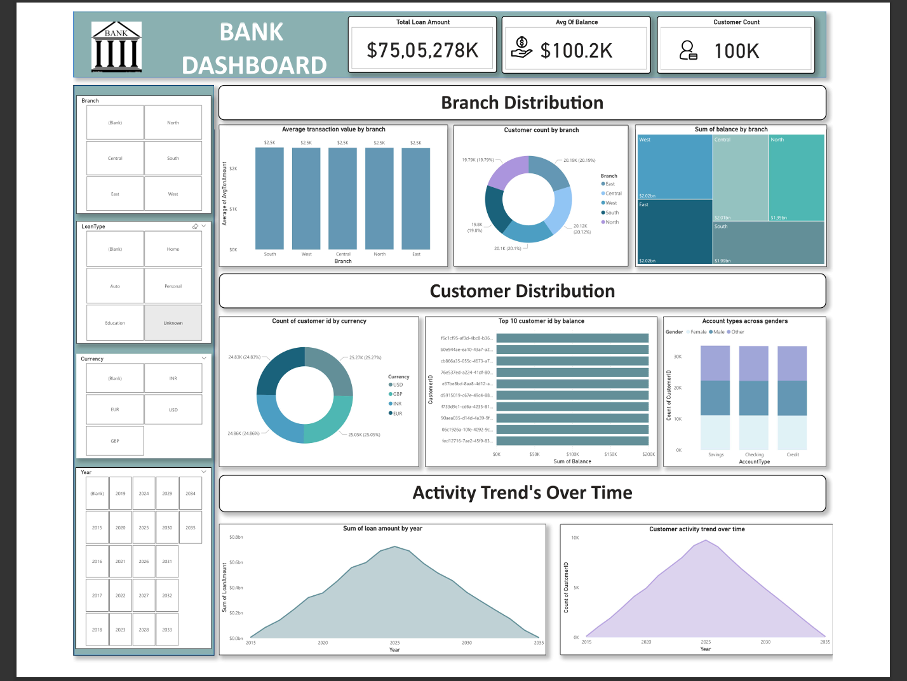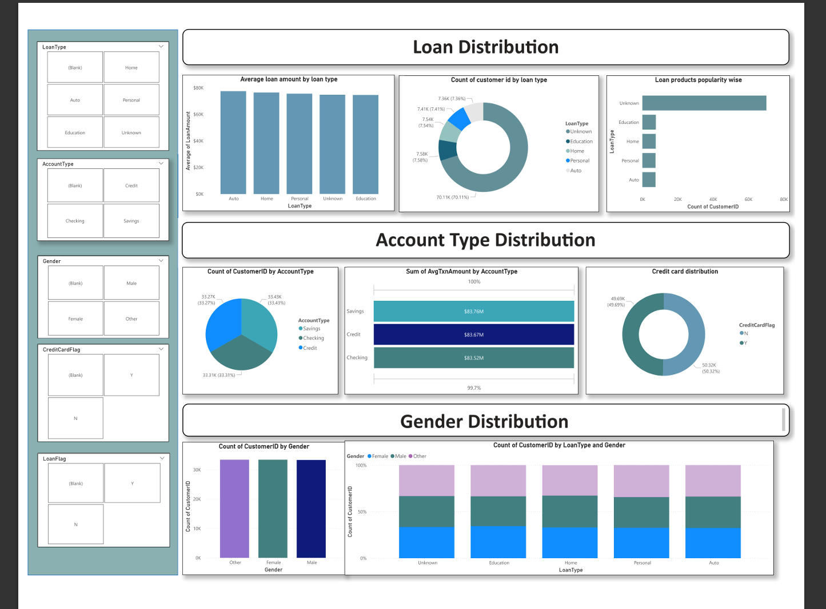

**C)Tableau Public Edition Dashboard:**

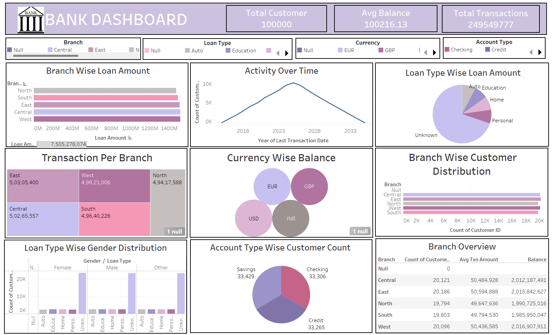

**6)Challenges faced :**

* In above dataset there is some amount of missing and null values these values are removed .
* The columns which not really important in the project are removed.
* Check the datatype of every column is correct or not if not it is corrected .
* Date and time formatting.
* Performance issue with large data.

**7)Conclusion:**

The Bank dashboard built in Excel, Power BI and Tableau offers a comprehensive overview of customer account activities, loan distribution, and credit utilization within the bank. By transforming raw transactional data into meaningful visual insights, the dashboard effectively highlights tracking financial performance, identifying trends, assessing risk, and supporting data-driven decisions for customer engagement and business growth.

**8)Future Scope:**

1. **Advanced Data Integration**

* Connect the dashboard directly to a live banking database or API for real-time updates.
* Merge with other datasets (customer demographics, branch locations, loan details) for deeper insights.

1. **Enhanced Data Visualizations**

* Add interactive drill-down features for branch-wise, region-wise, and customer segment analysis.
* Include trend analysis charts to forecast deposits, withdrawals, and customer growth.

1. **Predictive Analytics**

* Implement machine learning models to predict customer churn, loan default probability, or high-value customer acquisition.
* Use historical data to forecast transaction volumes and seasonal trends.

1. **Automated Alerts & Notifications**

* Set up automated KPI alerts (e.g., sudden drop in deposits or surge in withdrawals).
* Email or message updates for key stakeholders.